Customer Segmentation at Dayona Car Dealership

**Model Results and Analysis:**

The model gave pretty good results. The model gave us 5 cluster that means 5 groups in that sense. Every group has same features but not the same values which is that what we need. Let’s take look on Gender feature of 5 groups. Here, Male = 0 and Female = 1.0

1. Group 2. Group

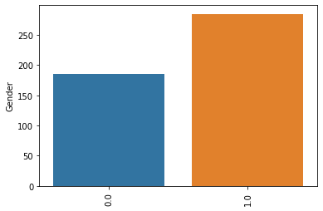 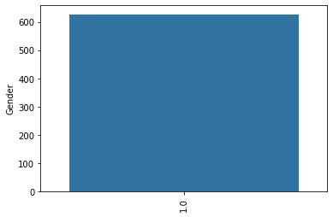

3. Group 4. Group

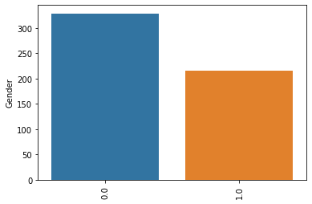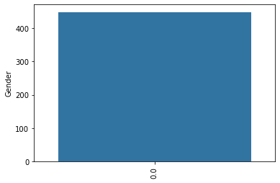

5. Group

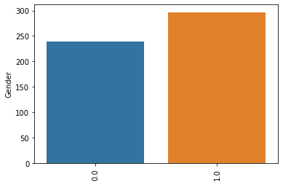As you can see, same feature but not same values. The model gives us insight for every group about gender. If dealer decided to take 4. Group for example that means company will lean more to the male customer and will invest into more of that. If dealer decided take 2. Group which is full female customer that mean they will invest into female customer. Let’s take look for another feature in those group which is “Profession” feature.

Profession feature we can say as customer jobs or major. Let’s take look in 5 group. Here, Engineer = 1, Healthcare = 2, Executive = 3, Marketing = 4, Doctor = 5, Artist = 6, Lawyer = 7, Entertaiment = 8, Homemaker = 9

1. Group 2. Group

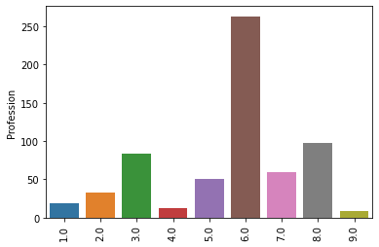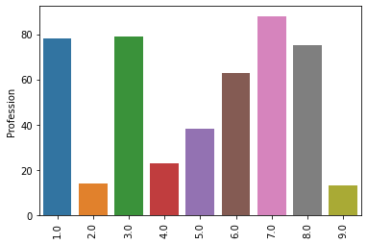

3. Group 4. Group

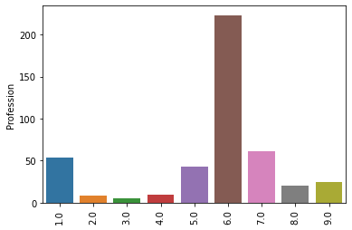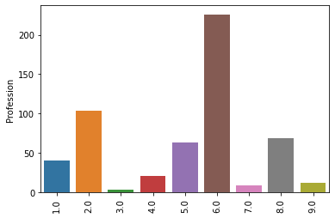

5. Group

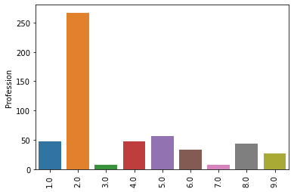 When we look into this Profession feature which is divided into for group by model, we can see that majority in these group is Artist profession. We can say that if dealer decided to go with 2, 3 and 4 group which is majority Artist in them, then dealer might be selling with cool looking and sleek design cars which would be very pleasant for Artist customers. If dealer decided to go with 1. Group then may be selling cars that will be good for everyone would be nice option.

As a result, the model gave us good results which is with different options. Managers of dealer can decide which group would be best and take that path.